

WEBSITE & DESIGN DEVELOPMENT

Website Design Document



# Website Goal



The website is called BOH for Booking HTU this website is dedicated for HTU students to reserve the class rooms available at the university to do group work, for example if students have a group project and they want to study together in a quite place they cant use the HTU’s library because they can be loud and they cant discuss there ideas freely so we provide a way for our students to use our unused class rooms to study in, this website’s goal is to solve an issue students at HTU have.

1- the website will be used by HTU students.

2- users in the website expect from this website: the users expect to have an easy way to fill forms of requests to have study sessions in the classrooms.

3- our primary aim in this website is to help student and make their studying experience at our university easier and more effective, contributing to their academic success.

Where we identify the purpose of our website usually in close collaboration with the client or other stakeholders.

# Scope

The website is designed for htu students to reserve classrooms for group study sessions it will cover scenarios where students need a quiet and collaborative space, where they can be free and not restricted from having dissections, the finished website will facilitate the booking of these classrooms, making it easy for student to find and reserve appropriate study environment.

Requirements

the primary function of the website is to allow the students to book available classrooms directly from the website, without any issues or complications in order to do that securely we need authentication process and to collect the data of the user

Requirement 1

booking form page in this page students will fill out a form that include their information and the information of the booking like time date number of students the room they want.

Requirement 2

viewing and modifying current and previous bookings: students will have a page of booking history to modify and see their previous booking

Sitemap



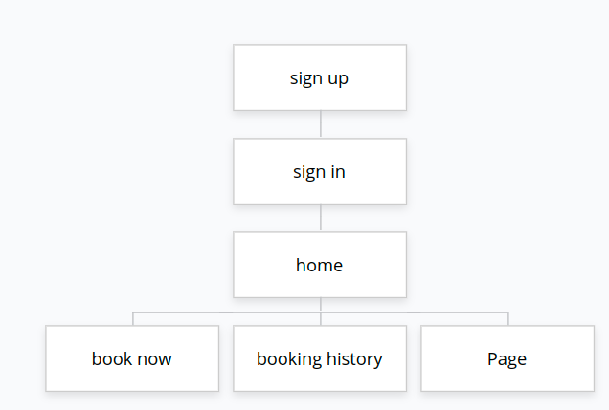

Wireframes for pc :

Sign up wireframe:

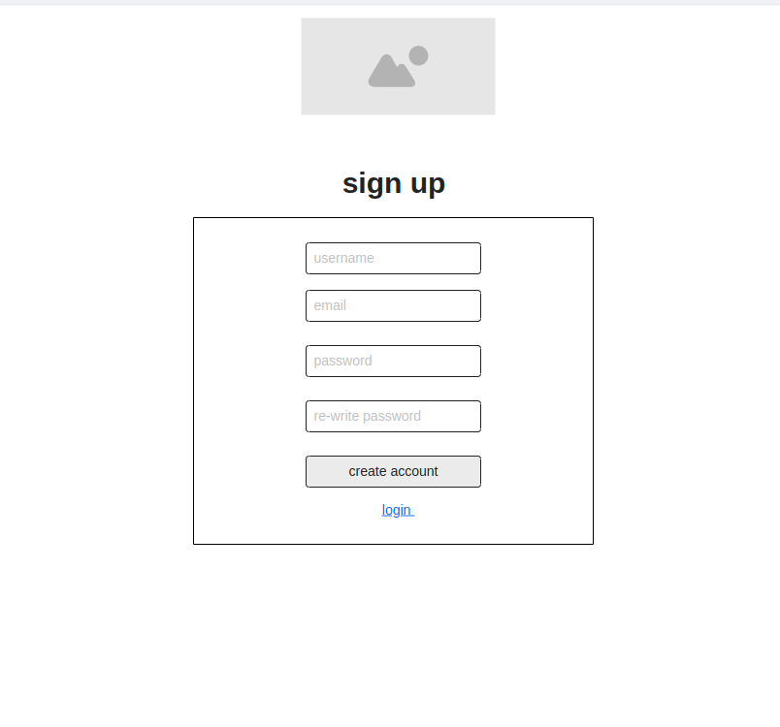

Sign in:

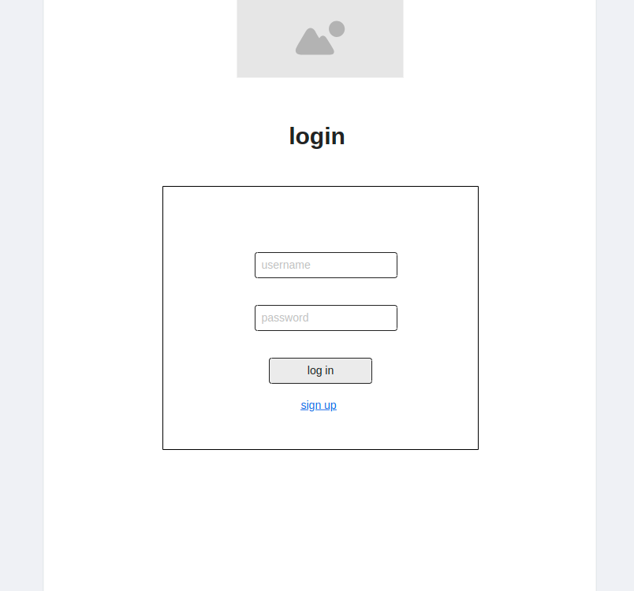

home:

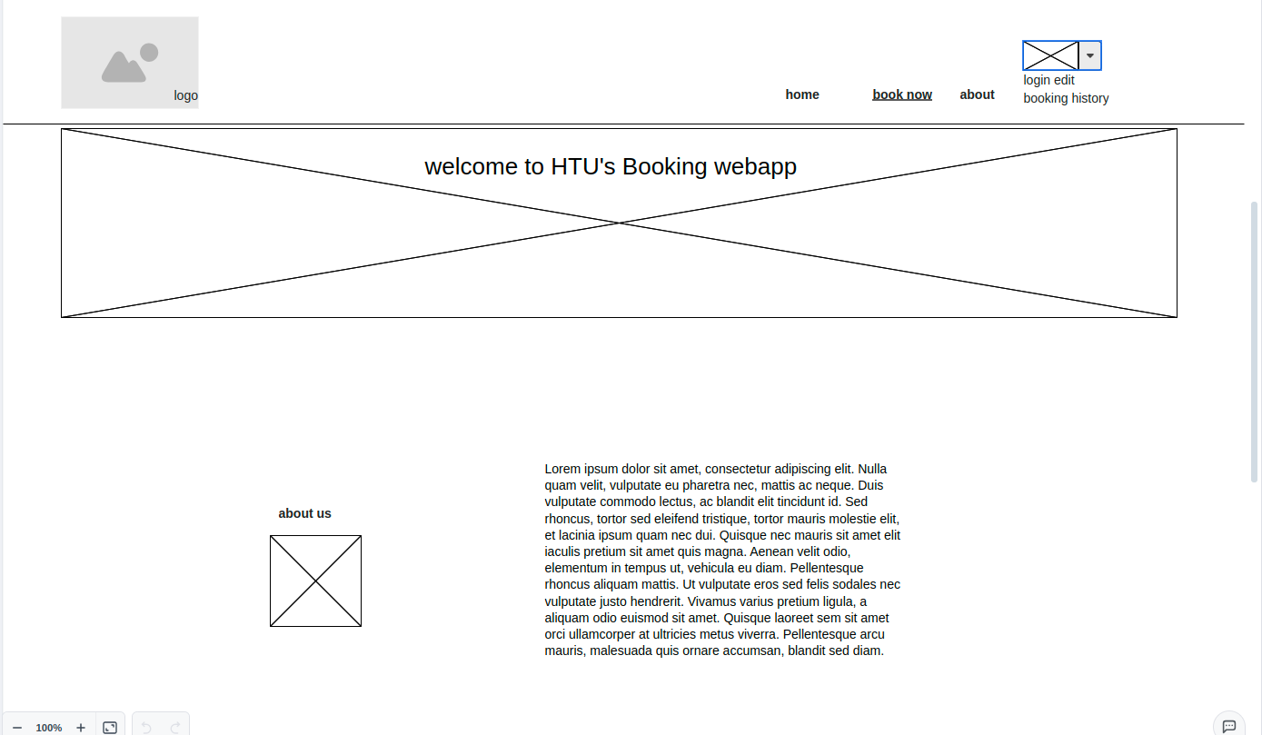book :

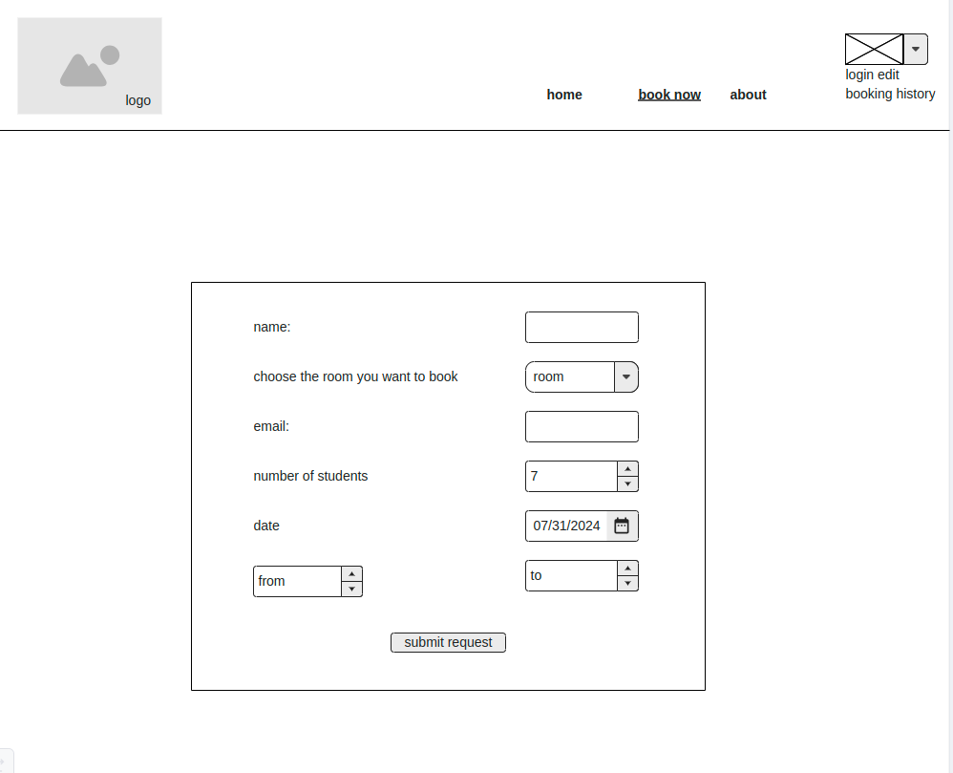

booking history:

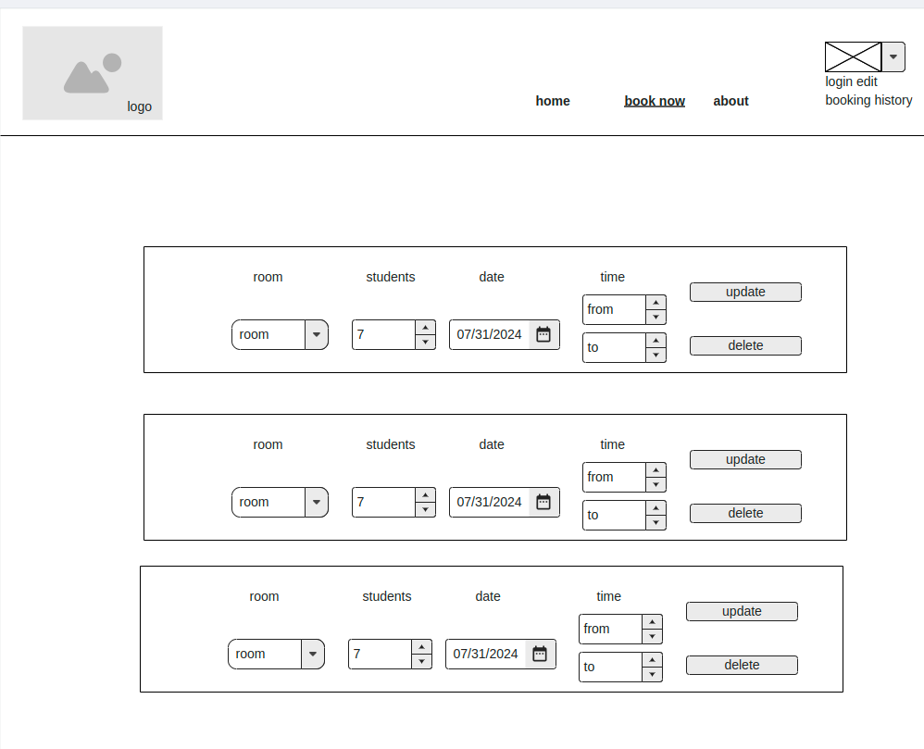

Wireframes for mobile devices:

sign in and sign up

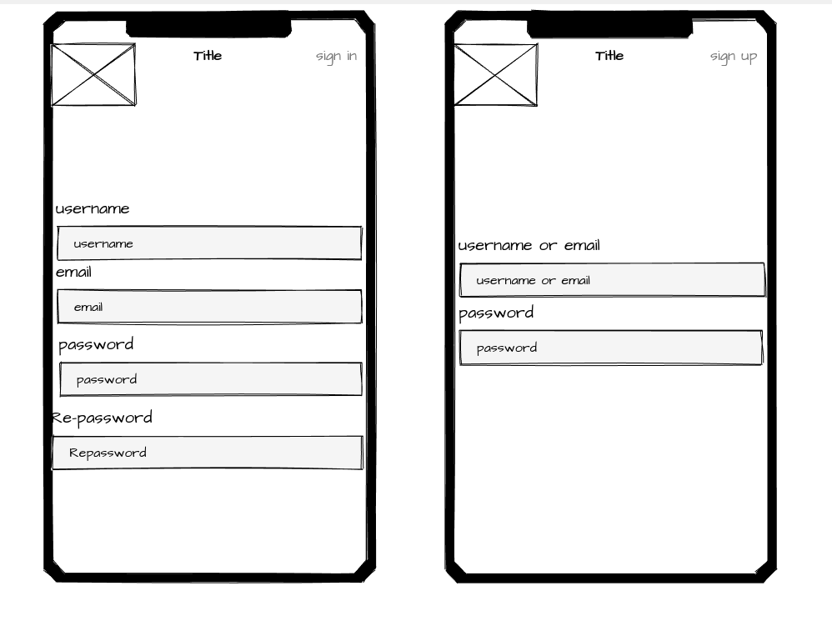

home

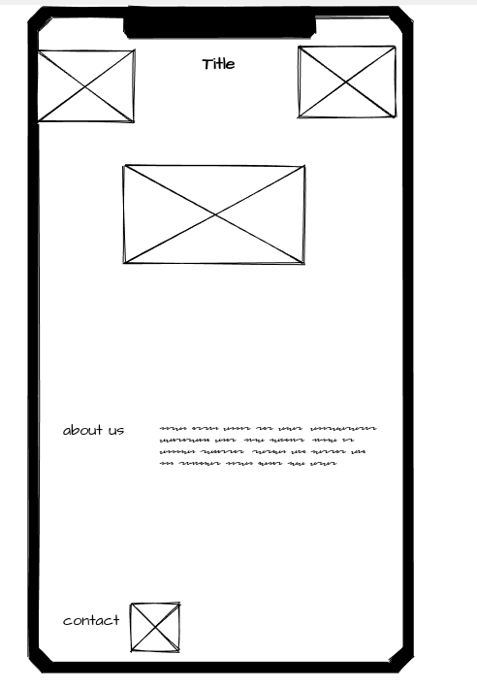

book and booking history

